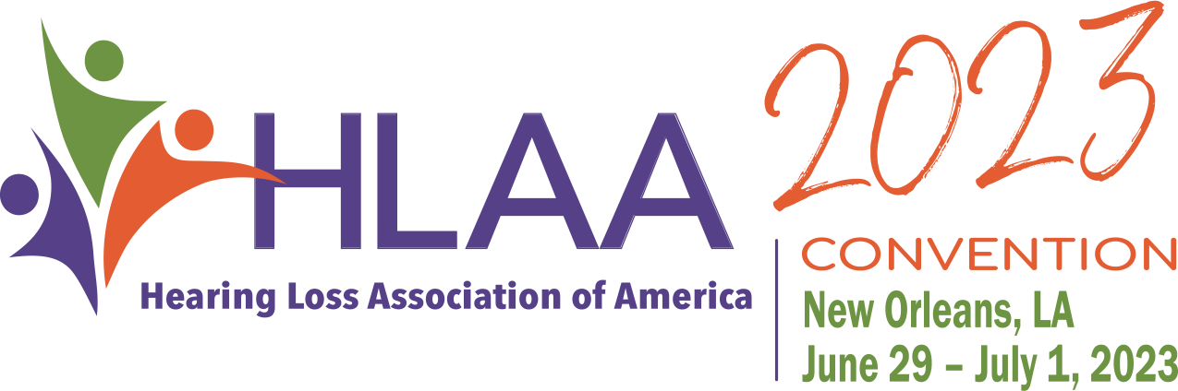

Hearing Loss Association America - Wisconsin (HLAA-WI)

Application Form

NOTE: APPLICANT MUST BE A CURRENT MEMBER OF LOCAL CHAPTER OR NATIONAL TO BE CONSIDERED.

Name ______________________________________________________________
Address ______________________________________________________________________________
City ______________________________ State ________________ Zip Code ______________________
HLAA Member ID ____________ E-mail ___________________________________________________
Best phone# to reach you ____________
Do you belong to a local Chapter in Wisconsin? If so, Name of Chapter ____________________________
Please provide brief answers to the following questions.
(Add a separate page, if needed)

- Have you attended a previous national convention? (Preference will be given to first timers.)

________________________________________________________________________________.

- Describe your involvement in HLAA, to date either at the national, state or local chapter level (this may include elected and volunteer positions and activities). _____________________________________

_________________________________________________________________________________

- What do you hope you will learn, gain, and experience by attending the convention? _______________

_________________________________________________________________________________

________________________________________________________________________________.

- What is the greatest challenge that your hearing loss presents to you daily that you hope the convention will address? _____________________________________________________________________________

_____________________________________________________________________________________.

Date: ____________________

Form must be received by March 31, 2023
Email to: hlaawistate@gmail.com
Or Mail to:
Convention Scholarship Committee
C/O Jerry Lapidakis
2169 Red Oak Court
Stoughton, WI
Email: jlapidakis@gmail.com

