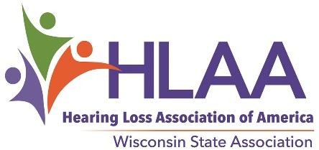

Application/Nomination to the HLAA-Wisconsin Board of Trustees

Name Title: Phone #:

Address:

E-Mail Address HLAA Membership # (Found on Magazine label)

I am: Hard of Hearing Hearing Parent of a Child with Hearing Loss (age of child)

Hearing healthcare professional Other: (Please explain)

If you participate in a local HLAA Chapter, please tell us which one

I understand that HLAA-WI Board Members must:

- Be a national member of HLAA in good standing (Membership in formation at www.hearingloss.org)
- Commit to a 3-year term on the HLAA-WI Board of Trustees
- Commit to attending 2 meetings at a central location in Wisconsin each year; time, date & place determined by the board
- Commit to participate in 2 online meetings each year
- Commit to corresponding regularly by e-mail.
- Be committed to the mission of HLAA: To open the world of communication to people with hearing loss through information, sharing, education, advocacy and peer support.

Please use a separate sheet of paper to explain why you are interested serving on the HLAA-WI Board. Include specific skill sets you have and tell us a little bit about your background.
I understand that HLAA-WI board members pay their own expenses to attend meetings. (Carpooling is encouraged & chapters are encouraged to offer support to their chapter members who serve on the HLAA-WI Board. HLAA-WI is a 501(c)3 nonprofit organization, therefore, mileage is deductible under IRS rules. Meetings generally do not require overnight travel.

Signature Date

2019 Nominating Committee:
Jerry Lapidakis, Chair jlapidakis@gmail.com Christine Klessig, State Board Member bommaklessig@gmail.com Jack Spear, Madison Chapter President jhspear@gmail.com

You may apply for the board yourself or nominate someone who would serve well; with their permission.

The current board offers opportunities in the following areas: PR/Marketing, Facilitating & Public Speaking, Parent Involvement, Walk4Hearing Committee, Fund Raising, Advocacy, Website Management, Newsletter Editing and Board Leadership. All based on board need and your unique interests.
Please fill out and return this application by mail or scanned e-mail to any of the members of the Nominating Committee, prior to October 1, 2019. The nominating committee will prepare a slate or ballot for election by the national HLAA members who reside in Wisconsin. The ballot, with a specified deadline, will be posted on the website, in the state newsletter, and will be circulated to HLAA members by e-mail. The elected board members will be introduced at the annual meeting on November 15th in Appleton.

